Climate Change and Wildfires
In 2024, California wildfires burned 763,425 acres which is near the size of Rhode Island and the fires destroyed 559 homes and commercial building, compared to a 5-year average of 200,000 acres. In 2023, 25,932 acres burned, while in 2024, the acreage is about 2,816% of the total for all of 2023 (Los Angeles Times). Recent years, I have heard a lot of wildfires news on TV and social media. I have even smelled the smoke when fires were near the UCLA campus. Wildfires have become one of the most visible, destroying and deadly consequences of climate change. They destroy houses, personal property and have a negative impact on ecosystems. The increasing number and intensity of wildfires worldwide are deeply connected to the rise of temperature and unpredictable precipitation caused by climate change. These factors come together to make wildfires more frequent, severe and longer. However, wildfires are not just a result of climate change—they also contribute to it and finally creating a death spiral. Wildfires exacerbate climate change, which, in turn, exacerbates wildfires. This paper examines the relationship between climate change and wildfire trends. By analyzing the change in temperature from average, precipitation levels, and the number of wildfire cases in the US, I aim to understand how climate change is increasing the number of wildfire cases, and finally give government policy recommendation to mitigate this problem.
In 1914-1918, governments around the world learned to mobilize and control an industrialized society, marking the start of global industrialization. Globalization and specialization production is also a mark of more severe climate change. Figure 1 is obtained from the United States Environmental Protection Agency, and it demonstrates the changes in annual average temperatures across the contiguous U.S. since 1901. The red bars represent years with above-average surface temperatures, while the blue bars represent the below-average years, compared to the 1901–2000 baseline. The yellow and green trend line represents the satellite data using two different methods. From the plot, between 1900 and 1980, the temperature was still close to the moving average, indicating periods that were neither extremely hot nor cold. However, after the economic boom of the 1980s, the temperature trended upward. The plot shows mostly red, indicating that each year's temperature was higher than the average and higher than the previous year. In addition, there were no blue bars after the 1990s, indicating that no single year was cooler than the temperature’s moving average.
Figure 2 is the precipitation level in the Contiguous 48 States from 1901 to 2023 (EPA). The green line represents years with annual precipitation above the moving average, while the brown line represents years with annual precipitation below the average. I used 1980 as a cutting line for the temperature, this can also apply to the precipitation figure. Before the 80s, I can see a clearly half green and half brown patterns. However, after the 1980s, I can see that green bars dominate. This means that years with excess rain are more common than before. This also proves that climate change is not only shown by increasing temperatures but also by excess rain and unpredictable precipitation. From these two figures provided by the governmental website, I have significant evidence to confirm that global warming in the past four decades is not just a claim; it is a fact.
With the confirmation of climate change has positive correlation with temperature and unpredictable precipitation. Now, I can analyze the effect of how these factors change the wildfire trends. Figure 3 presents the western U.S. trends for number of large fires in each ecoregion over time (Dennison et al., 2014). The data used in the figure are from the MTBS project, which maps large fires in the U.S. using satellite data, focusing only on fires over 1,000 acres west of 97° longitude. Analysts compare satellite images before and after fires to outline burned areas and use these images to determine the area burned. The different color polygons represent different ecoregions, and the histograms show the number of fires over time in those regions. The black lines on the histograms are the trend lines for the number of wildfires over time. As most of the histograms show, other than California, the rest exhibit a positive trend over time, reaffirming that more severe rises in temperature and more unpredictable precipitation are positively correlated with more wildfire events. In addition, the histogram also shows significant cyclical patterns with a peak every 4-5 years. This is reasonable: with excess rain, vegetation grows stronger and quicker. When vegetation reaches a certain density and higher temperatures prevail, it becomes more susceptible to burning, leading to peak numbers of fires.
Figure 4 summarizes how climate variables like temperature (Tmax), precipitation, and drought severity (SCPDSI) correlate with wildfire trends across different regions in the western U.S. The red diamonds illustrate the direction and strength of trends for several factors: the number of fires, the size of fires, and the seasonal timing of fires, alongside climate-related variables. Larger diamonds represent stronger trends, either toward more fires, warmer conditions, drier weather, or higher drought severity (Dennison et al., 2014). This figure shows how climate change drives different precipitation levels, temperatures, and how these, in turn, drive wildfire activity in complex and regionally varied ways.
To protect citizens' personal property and mitigate wildfire damage and climate change, the government should implement climate mitigation policies, better urban planning, and enhanced monitoring using satellite technology. First of all, government should take proactive role to reduce carbon emissions. According to the EIA, the transportation sector emitted approximately 31% of total carbon emissions in 2023 (EIA). So, if the government can reduce emissions from the transportation sector by changing cars and planes to greener alternatives, this will significantly reduce carbon emissions and contribute to mitigating climate change. For example, the government could mandate a switch to new energy vehicles by a certain date and impose higher carbon taxes on large airline companies. Secondly, we can adopt more remote sensing technologies, such as the Monitoring Trends in Burn Severity (MTBS) project. This project uses satellite data to map the boundaries of burn areas across the United States, and the government might expand the use of this project, such as, gaining information about areas with overgrown vegetation. Considering the cyclical pattern of peak fire occurrences every 4-5 years, we can closely monitor vegetation changes and take proactive measures to control overgrown areas, thereby preventing these peak periods. Reducing the likelihood of wildfires could be one way to mitigate climate change. Lastly, the government should use Figure 3 to rank fire zones from high risk to low risk based on historical data. For high-risk zones, it should restrict all kinds of development to minimize potential damage in the event of wildfires. For low-risk zones, the government should still inform residents and developers about the potential risk of wildfires, emphasizing that total property loss is possible, even in low-risk areas.
In summary, this analysis confirms that climate change has a significant impact on rising temperatures, increased rainfall, and unpredictable precipitation patterns, all of which contribute to a higher frequency of wildfires. Excess rainfall leads to overgrown vegetation, while higher temperatures act as ignition sources. The overgrown vegetation then serves as fuel for these fires. More frequent wildfires release more carbon dioxide into the environment, further exacerbating climate change and leading to increased temperatures, unpredictable precipitation and more extreme weather events. This creates the death spiral. Government should lead the role to address climate change problems, such as encouraging residents to adapt to greener transportation modes, charging higher carbon taxes, using more advanced technology to monitor not only fires but also overgrown vegetation.
Figure 1: Temperatures in the Contiguous 48 States, 1901–2023
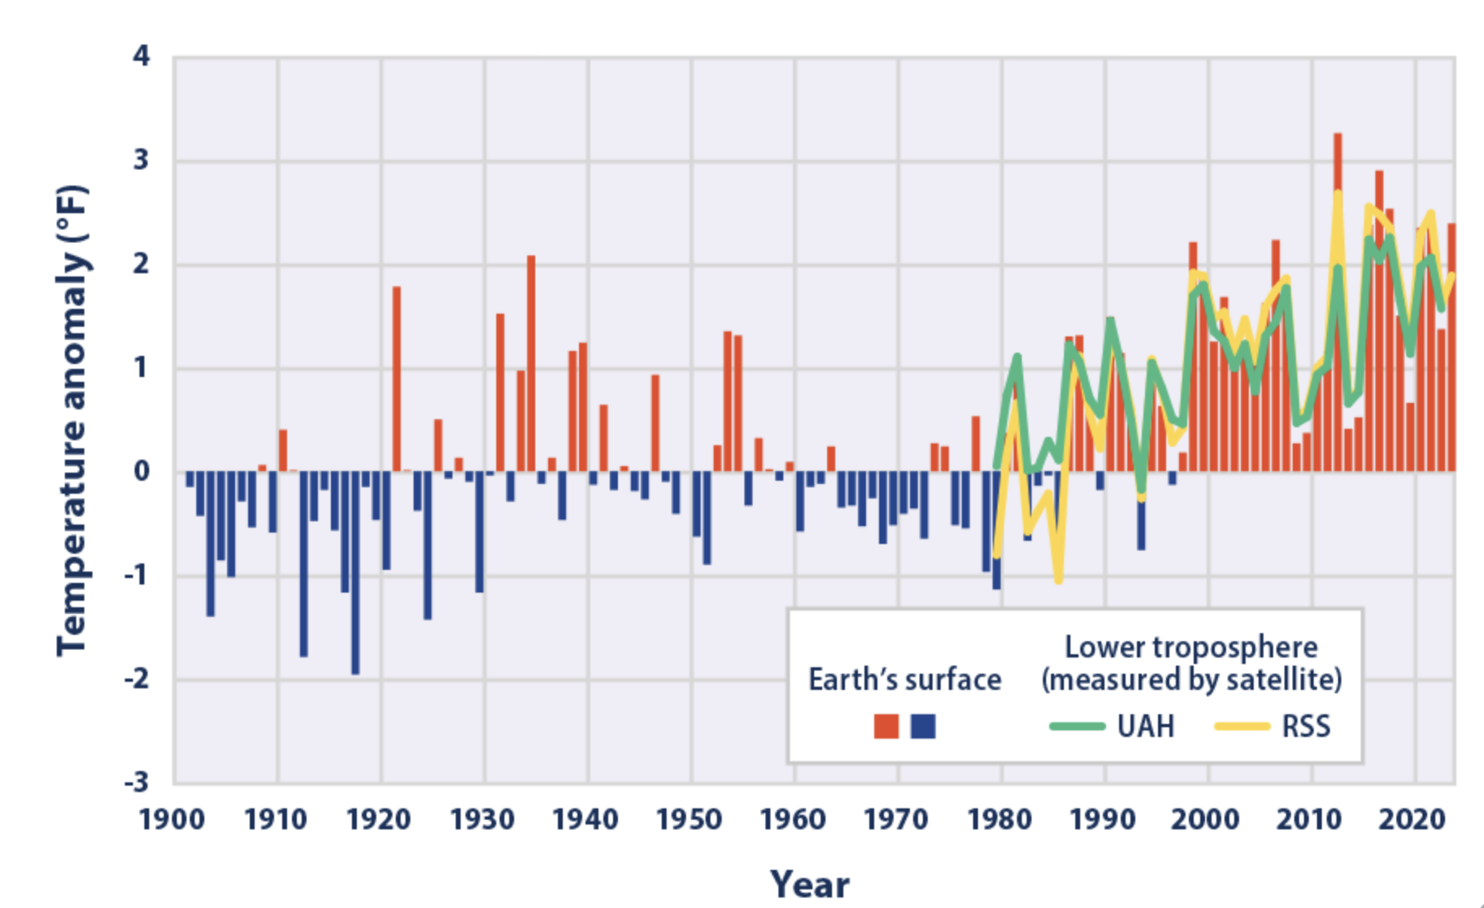
Figure 2: Precipitation in the Contiguous 48 States, 1901–2023
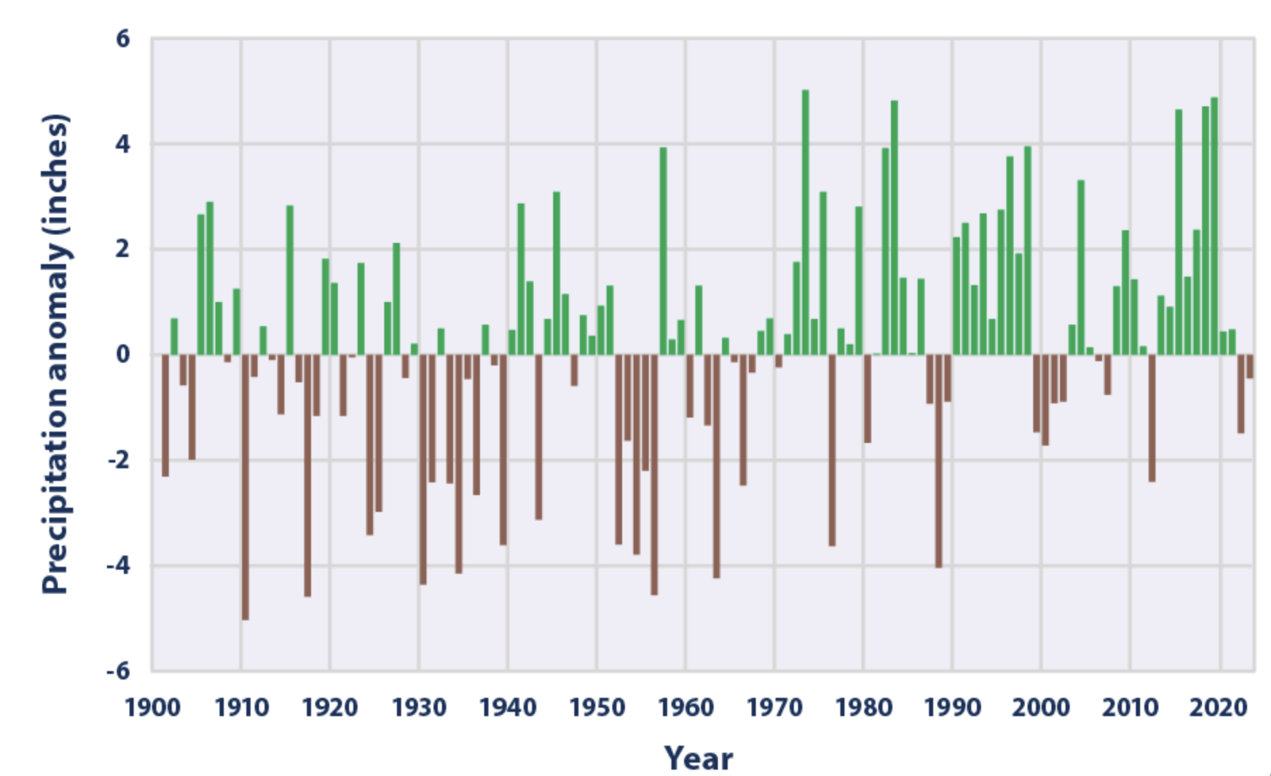
Figure 3: Western U.S. trends for number of large fires in each ecoregion per year
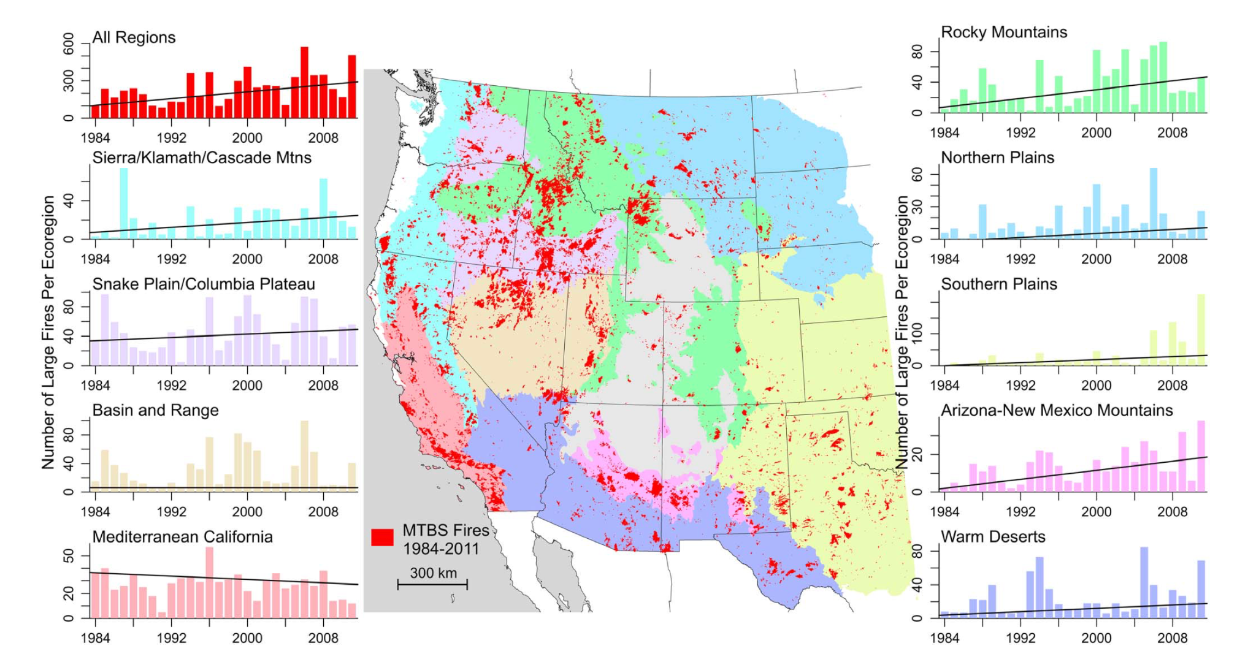
Figure 4: Likelihood for fire and climate variable
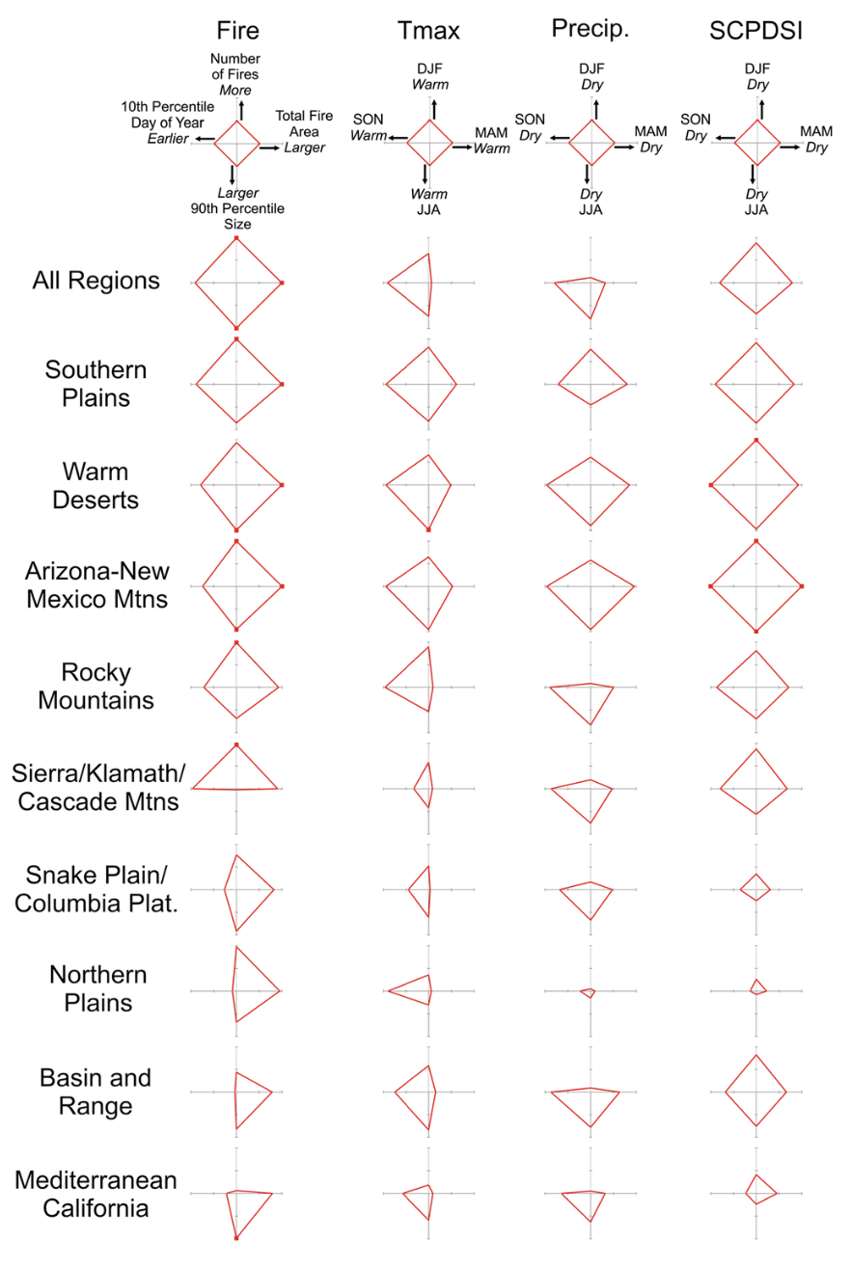

Work Cited:
"California Wildfires Have Burned 750,000 Acres so Far This Year." Los Angeles Times, 31 July 2024, https://www.latimes.com/california/story/2024-07-31/california-wildfires-have-burned-750-000-acres-so-far-this-year.
"How Much Carbon Dioxide Is Produced from Burning Gasoline and Diesel Fuel?" EIA, https://www.eia.gov/tools/faqs/faq.php?id=307&t=10.
"Climate Change Indicators: U.S. and Global Precipitation." EPA, https://www.epa.gov/climate-indicators/climate-change-indicators-us-and-global-precipitation.
Dennison, Philip E., Scott C. Brewer, James D. Arnold, and Max A. Moritz. "Large Wildfire Trends in the Western United States, 1984–2011." Geophysical Research Letters, vol. 41, 2014, pp. 2928–2933. doi:10.1002/2014GL059576.

